Personal Study Plan
Define the objective or focus of the essay:
The absence of light in photography.
In order for a photograph to be taken and seen, it requires light. But then why do some photographers take photographs at night when there is no light?
The focus of my study is going to be the absence of light in photography, im going to be using the photographers Brassai and Edgar Martins who both taken their photographs at night with the absence of light in their images.

“Night does not show things, it suggests them. It disturbs and surprises us with its strangeness. It liberates forces within us which are dominated by our reason during the daytime.”
― Brassai
“In some, sky and ground merge in darkness with only the lights and airport hieroglyphics to orient us.”- Edgar Martins

The relationship between the practical work and the focus of the study:
For my first stage, I plan to take pictures in Liverpool at night, these images will be black and white and the weather will be cold and rainy therefore making the images dark. These images will be inspired by Brassai’s work as his images are usually edited to black and white with foggy, cold weather. My images will be inspired by Brassai’s as well as being inspired by Edgar Martins, he took his images at night which is what I plan to do but his night images usually only have one thing in focus which is what I plan to do in some of my images. Although Edgar Martins and Brassai’s work aren’t the same, they have similar ideas due to the fact they both take images at night and there is usually an absence of light. These photographers very clearly use different techniques when taking and editing photographs, I plan to use both of these photographers as inspiration in my first stage, in different ways.
Sources to be used:
Books (at least THREE): | Websites: | Other sources:
Twilight: photography in the magic hour  Brassai: Paris by night  Brassai: Paris after dark | https://www.holdenluntz.com/magazine/photo-spotlight/brassais-secret-paris/  https://proedu.com/blogs/photographer-spotlight/brassai-paris-at-night-and-the-poetics-of-light-capturing-the-citys-nocturnal-soul?srsltid=AfmBOord1vNbHnUj8O_OJsy8a7kI0g5oigbg1M8cc-LaejTL03BeSua9  https://edgarmartins.com/product/when-light-casts-no-shadow/  . https://lenscratch com/2009/07/edgar-martins/ | https://www.youtube.com/watch?v=ER7Om5MWXdI  https://www.youtube.com/watch?v=2E1eGWSSPAQ  https://edgarmartins.com/videos/

List the pieces of work that you will analyse in the study. Identify reasons for choosing these particular pieces and points that may be highlighted in the analysis. Mark the primary source/s with *
Name of piece: | Reasons for choice/Points to be raised:
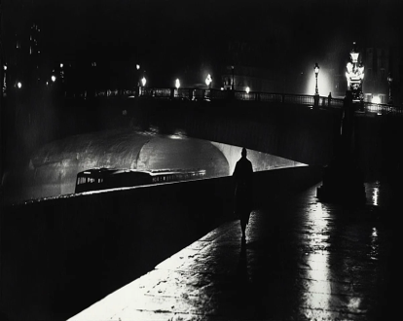  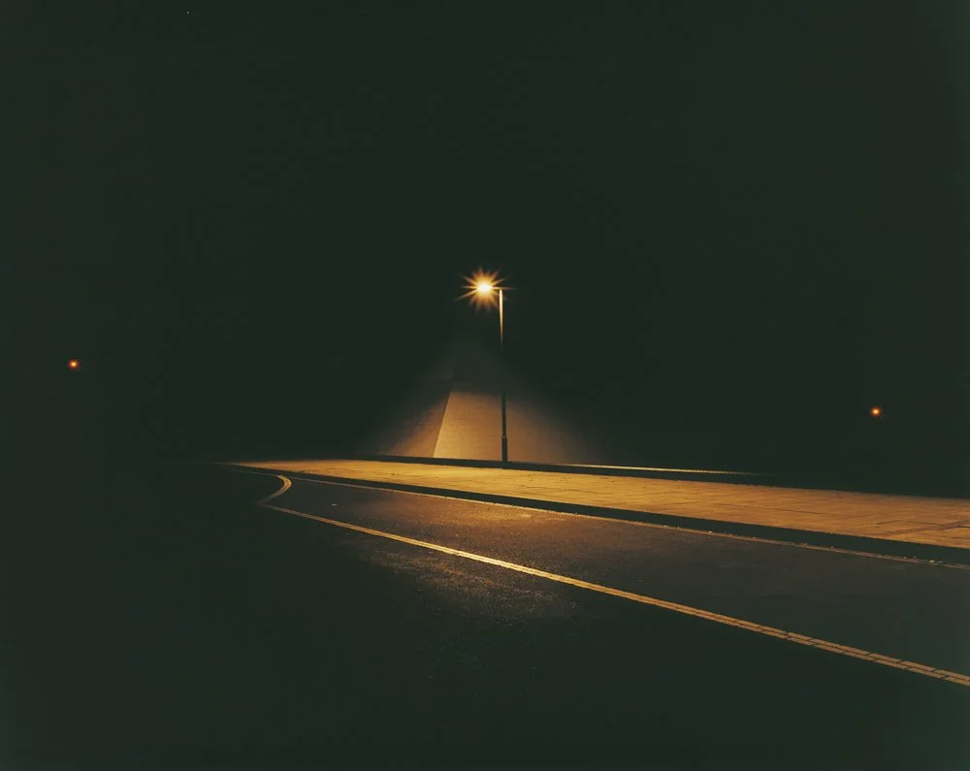  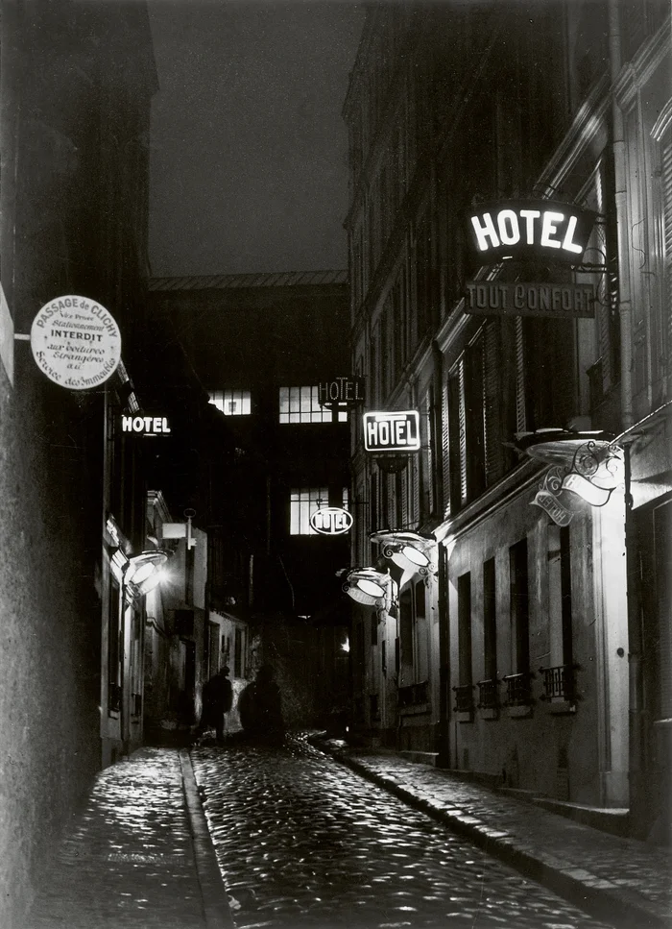 | This image taken by Brassai really stands out to me as this image clearly has a very low contrast, the image does not have much light but it still conveys a lot about Paris at night, it shows ‘a hidden world of nocturnal beauty and intrigue”. This image is very captivating as it shows the little bits of light but the remainder of the image has an absence of light, it shows shadows, it shows a person and a form of transport, it is showing a lot of things all in one image and shows the unique perspective that Brassai had.  The editing technique in this image stands out to me most, the image is not in colour but it is not just fully black and white either, it is a unique editing technique which really brings out the shadows and the textures in this image which creates a more intriguing atmosphere.  This image by Edgar Martina uses leading lines on the lines of the road and the light that creates a path, this is what makes this image more eye-catching. I like how he has used the middle ground as a focus in the image, whilst the background and foreground are overall just dark and not very drawing for the viewer, I think this makes his image more unique and makes the image better to focus on and more captivating for viewers.
Visit/s made/to be made:
Liverpool, potentially Manchester
Possible conclusion/s to the study:
To take a photograph light is needed, isn’t it? Then why do so many photographers have an ‘absence of light’ in their images. In my personal study, I plan to research night photographers like Brassai and Edgar Martins and see why they are so drawn to taking pictures at night with the ‘absence of light”.

