Introduction-
In order for a photograph to be taken and seen, it requires light doesn’t it? So why do some photographers take photographs at night, when its dark and no natural light?
A photographer who uses the absence of light in photography is Brassai, best known for his series ‘Paris at night’. This series is full of images taken at night in Paris, he stayed in Paris in the 1930s and explored the streets at night. Brassai is was a Hungarian-French photographer and sculptor who became known around the 20th century. His images capture the essence of night life in Paris, he highlighted the beauty of night which not many see.
Another photographer who also uses the absence of light in his photographs is Edgar Martins, whose images capture mystery and darkness. Edgar Martins night images use darkness and different shadows, they are quite unique compared to other night images by different photographers as they explore different concepts like the nature of reality and absence. Edgar Martins took his images at different places, one place being the Azores.
However, both Brassai and Edgar Martins focus on taking images at night when its dark, no natural light, this essay will be using these photographers to explore the absence of light in photography.

“Night does not show things, it suggests them. It disturbs and surprises us with its strangeness. It liberates forces within us which are dominated by our reason during the daytime.” Brassai.

“In some, sky and ground merge in darkness with only the lights and airport hieroglyphics to orient us.” Edgar Martins.

Conclusion-
In conclusion, both Brassai and Edgar Martins use the absence of light in their night photographs, both use shadows and superficial light to make their images more eye catching for the viewers. Brassai’s images in Paris, highlight the importance of unseen aspects of the city

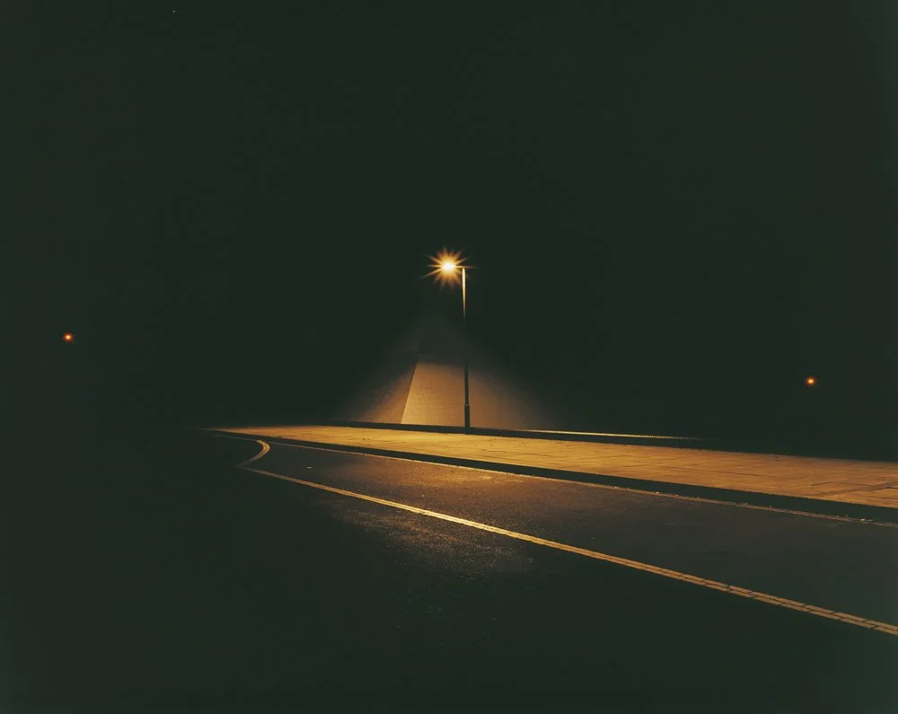
This photograph by Edgar Martins has an interesting composition, the street is lit by a single street light, it is keeping within its content. The colour scheme of this image is orange and yellows but not too bright which gives the image a gloomy atmosphere. This work seems to have a low contrast and is vivid in some places like the light but then subtle in other parts of the image like the background where it seems to be all dark. The orange, yellow colours where the street light is, is more dominant than the other colours. This image uses different tones to focus of the light and the shadow from this, the forms in this image feature the road and the light, making these parts more eye-catching for the viewers. This image does have a variety of unity of texture due to the colours and different tones within the work. The subject matter of this image is the street at night lit up by a singular street light, the image focuses of the lighting of the street and it is of importance as it is the main focus of the image. This work seems to focus more on the atmosphere and the light in the image rather than communications, however it could potentially be communicating socially as there is no people in this image so the work may be aimed socially at people who do not go out and explore at night time. Based on the work, I think that the subject matter of this image was observed and the intention was potentially to treat it representationally as it represents the streets at night and not many people see this which is shown in the image as there is no one around. The content in this image is immediately apparent as when you look at the image, you immediately see the street light and the surroundings of this. Edgar Martins usually used a Toyo Mark 2 8x10 field camera to take his photographs. From this image, it looks like he has used slow shutter speed to capture this due to how the light streaks in the image. It looks like he has used techniques like a single light source. He may have used sketches to support his images, to make them overall better and more eye-catching to the viewer. Due to the colour scheme of this image, it seems as though the image was evolved over time, the artist must have had good technical skills and good patience in order to produce this work as he had to wait till night to capture this image. This images affects me as it creates a sense of mystery, there isn’t much going on in this photograph, for example there is no people, it makes me wonder if there was people in this image that we cannot see due to the darkness in the image. It creates a sense of loneliness as it seems Edgar Martins was alone when producing this work, there isn’t anyone around him. It conveys feelings about life as the world looks completely different in the light, it looks as if no one has been there, there isn’t mess and litter and big groups of people, it looks peaceful, quiet and calm. Edgar Martins created this work, it was created at night in Europe. This work shows this as its all darkness with parts being lit up by a street light. This work could potentially have elements in common with other art forms in that time, like poetry, this is because I feel as though it tells a story like poetry also does. I think this work was made for everyone at that time, to show them how different things at when we are asleep, how peaceful it is. Edgar Martins other work that was made at night, all link to this piece of work, he has images done near and at airports at night which all links to this image as they are all taken at night to show the difference between night and day. They are similar to this work in small ways like the time of day the images were taken but the atmospheres are slightly different.

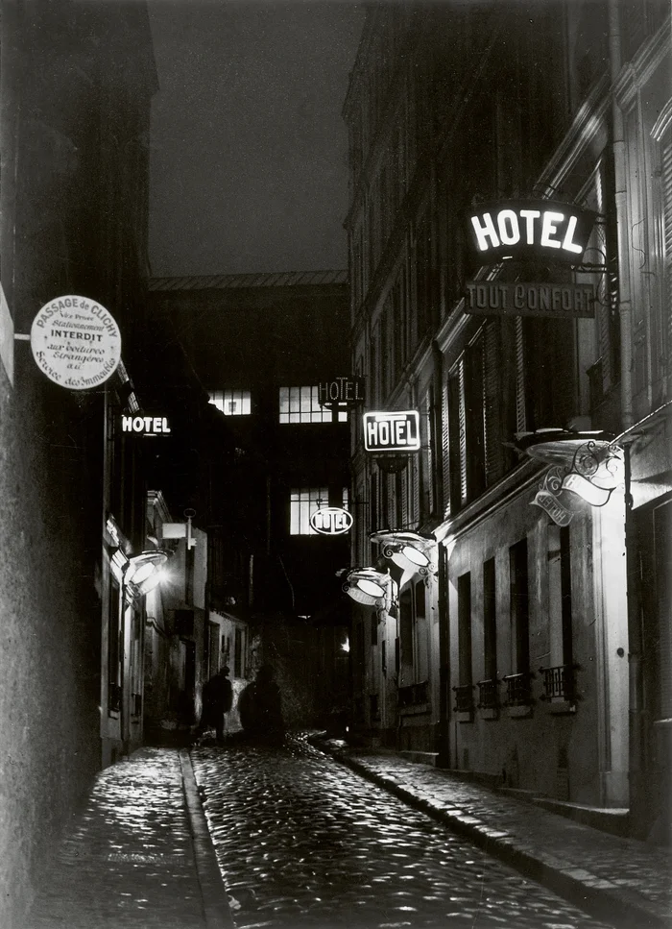

The arrangement of this image looks like Brassai is trying to capture the heart of a street, the colour scheme is quite dark which will make people think this image is old, it looks as if Brassai is using low contrast. The texture of the road is wet which makes the lights reflect from it, I can see this image uses leading lines, this is shown on the buildings which creates a sense of depth and it draws you to the image. The subject matter of this work is the streets of Paris at night, not many people see them so Brassai is bringing them to light, showing the different between night and day, it’s a communication for social concerns potentially as its about a city at night. Looking at Brassai’s series, ‘Paris at night’ the subject matter is based on observation as he walked through the streets of Paris at night. Brassai said “Night does not show things, it suggests them. It disturbs and surprises us with its strangeness”. This shows that Brassai’s intention was to treat it representationally. The content in this image is immediately apparent as it shows the night streets of Paris, it shows the darkness and the hotels. Brassai was known to use a Voigtlander Bergheil camera with fast aperture for his night photographs in Paris. He often used long exposure, like putting his camera on a wall, he used all the available light like street lights and signs, for example the hotel sign, in his photographs. It is also said that Brassai used different printing techniques to boost the atmosphere of his images. Brassai’s night series was evolved slowly over time. To create this photograph, Brassai must have had a strong understanding of low light photography and patience as he used long exposure. He also must have had good technical skills to create his images. This work affects me creatively as it makes me feel as though I am missing out, exploring the city streets at night, it makes me feel as though I should go and do the same thing to experience everything the way Brassai did. It conveys feelings about life and how different it is at night, in small ways, like using streets lights to see instead of natural light, and the different people that are out at night compared to during the day. I would say this work is quiet, there isn’t many people around and the atmosphere looks dark and sad due to this but it seems quite relaxing as its not as loud and busy as it would be during the day. Brassai created this piece of work is Paris at night time, the evidence that shows this is the darkness in the image and the lack of people. This work has elements like the darkness and black and white in common with films during this time, the gloomy aspect due to the colour scheme employed. This work was made for people all around the world, to show them what the city of Paris looks like when most people and sleeping, to show them the difference in atmosphere, to show them the difference in overall looks.
In order to take a photograph, for it to be seen, there has to be light, so why are so many photographers obsessed with the absence of light?
In Brassai’s series of photographs of ‘Paris at night’ he ‘captures the nocturnal soul’. In this image in particular, it has a strong composition and has available light instead of superficial light, we see this as there are street lights making this image bright, adding some light. This photograph focuses on setting mood and character as the darkness in the image creates a sense of isolation and mystery. The colour scheme in this image is quite subtle as it’s a mix of black, white and grey in certain places followed by some light, it creates tone and contrast within the image. In this image, there are a variety of textures including; smooth to rough in certain areas like the tunnel for example, and then matte to reflective, when the light shines from the floor. The image holds together as the overall entity of the image is consistent as there is the use of recurring shapes like the pattern of the pavement. The subject matter of this work is the night life in Paris, it has an abstract composition and it shows the importance of the things people may not notice as many people miss out on the night life in Paris. The focus of this is the person walking and the lights highlighting potential feelings of this person, the focus could also be what is going on around this person. This image could be trying to communicate social concerns as Brassai’s series that includes this image is the ‘nocturnal soul’. The image is overall communicating the experience of Paris at night through the tones in this image, through the rhythms in this image. This image is likely to be imagined as it is abstract composition, this is because it focuses on the visual elements in this image like, the bridge and the pathway at night, the contrast between the dark areas and the light areas. There may be hidden aspects in this image as it can represent different things to different people, some may thing it represents loneliness, whilst others may think it purely just represents the night life in Paris. The content in this image is not immediately apparent as the image is very dramatic, the composition and the lighting may create a more complex visual experience for the viewer. This was made with a tripod, with a mounted plate camera and a magnesium flash or potentially flash powder to illuminate his images. Brassai used different processes and techniques to create his images, like exposure timing, for example the duration of cigarette smoke to help him get the photograph at the perfect time. He also used darkroom manipulation. Brassai walked at night time, finding people and objects that he found interesting, that he could photograph, he sometimes staged scenes.. Brassai used careful observations to ensure his images were exactly how he wanted them. His process also included doing drawings and sketches, sometimes writing, to ensure he got his images to how he wanted them. Brassai explored the city of Paris with his “eyes and hands”, his images don’t “show things, it suggests them” as Brassai said. Brassai spent years on his Paris images, his images evolved over time. Brassai had and used a variety of skills whilst producing this piece of work, he had technical skills, he had composition skills, he had conceptual skills, he had observational creativity, he had historical and cultural knowledge along with many more that he used throughout his ‘Paris at night’. This work by Brassai affects me in many different ways, it makes me feel joy through the light, whilst also making me feel sadness through the different contrasts in his work. It makes me feel appreciative for the different elements in this image. This image captures the feeling of isolation through the person walking alone at night. It creates a mysterious atmosphere through the darkness, it leaves the viewer wondering as it conveys mystery and the unknown. This captures ‘Paris at night’, the light reflecting from the wet floor creates a sense of mystery. Brassai may have felt a sense of wonder when he took this image, a wonder about what the world is like at night, if it’s any different at night and if so then how, he may have felt determined to see this and figure this out. This work is quiet and has a dark atmosphere, its relaxing as it seems like a quiet time of night, there doesn’t seem to be many things around. The light shadows in this image create an atmosphere through the composition and the darkness, it makes the viewer feel curious, these things make the image effective. This image was created by Brassai, followed by many other images in his series, ‘Paris at night’, the ‘nocturnal soul’. This image was made in Paris at night, I know this because of Brassai’s book ‘Brassai: Paris by night’ and because of the darkness of this image with hints of light. Brassai said “to me photography must suggest, not insist or explain.” This highlights Brassai’s mindset when taking these images. This image may have elements in common with other art forms during this time like film for example, this is because the image is using black and white and films then and photographs focus on atmosphere and mood. This may have been made for people in Paris as Brassai explored at night, potentially so they didn’t have too. His whole ‘Paris at night’ series is similar as they all link.
